How to get started with PEDAL
- Check out PEDAL anywhere that is accessible to QTP (shared drive, local drive to QTP box, etc.)
https://ncisvn.nci.nih.gov/svn/qa/trunk/Tools/PEDAL_QTP/
  - Create a new folder with right click→New→Folder
  - Right click the folder and select “SVN Check Out”
  - Provide the URL above
  - Click OK
    - 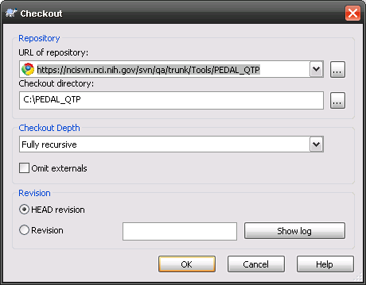
- Create Application specific directories
  - Automatically
    - Double click on the file called create_directories.vbs located in the root PEDAL directory (i.e. C:\PEDAL_QTP)
    - In the messagebox, provide a name with no spaces and click OK
    - Note: This also creates a blank object repository for you in the correct location with the correct name. If you already have one, it will not replace it.
  - Manually
    - Copy this directory and rename to your project name, but with no spaces:
\data\Project_Name_With_No_Spaces
    - Rename of the following directories to your project name, but with no spaces:
      - \tst\proj_object_repository\ Project_Name_With_No_Spaces
      - \results\Project_Name_With_No_Spaces
    - Create your object repository
      - in QTP and save it to \tst\proj_object_repository\your_project_name
      - The Object Repository file must have the same name as the directory
      - When you open the Object Repository, the name at the top of the hierarchy on the left must also be the same as the directories and file name.
- Create a Test
  - Copy this file up one directory and rename appropriately: \data\project_name\Templates\PEDAL Template of Templates.xls
- Create a Template based off the test and store in “Templates” directory
- Create a bunch of Tests using the Template
- Create a batch of tests

